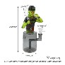
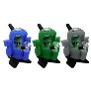
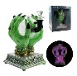
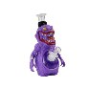
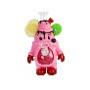

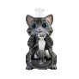
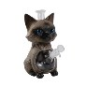
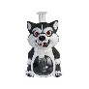
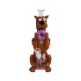
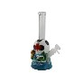
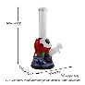

YHS SUPPLY LLC Address: 135 N ASPAN AVE, UNIT4, Azusa CA 91702

Contact: Flora WhatsAPP: +86 181 2703 5561

Stock in CA warehouse

Valid for: 3 days

Product No. Picture Weight SPECS
Landed Price by USPS

Stock

9'' Baseball man water pipe

Mechanical alien water pipe

7.5'' pvc divination hand water pipe with light and voice

8.6'' Mutated eggplant water pipe

8.8'' Cake man water pipe

8.2'' Pink dress female mouse water pipe

9.4'' Shorthair cat water pipe

9.4'' Siamese cat water pipe

9.2'' Husky water pipe

11.2'' Scooby-Doo water pipe

10.4'' Maple leaf soccer water pipe

10.2'' Golden gate water pipe

CY013 273 g

CY015 350 g

CY019-E 489 g

H622 450 g

H621 524 g

H617 440 g

H609 528 g

H608 515 g

H602 437 g

H601 426 g

H597 403 g

H596 428 g
pvc+glass 230*106*124mm

silicone 181*106*136mm

pvc+glass 214*125*151mm

pvc+glass 220*135*145mm

pvc+glass 225*125*150mm

pvc+glass 210*125*130mm

pvc+glass 240*130*210mm

pvc+glass 240*130*220mm

pvc+glass 235*135*190mm

pvc+glass 290*115*155mm

pvc+glass 265*105*155mm

pvc+glass 260*100*160mm

$25.5 130 pcs

$17.9 333 pcs

$28.8 116 pcs

$18.9 180 pcs

$21.3 160 pcs

$17.8 150 pcs

$23.5 320 pcs

$23.0 240 pcs

$22.0 128 pcs

$23.1 162 pcs

$21.7 103 pcs

$19.8 180 pcs

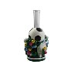
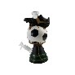
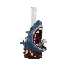
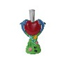

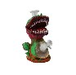
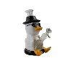
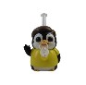
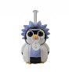
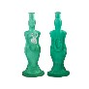
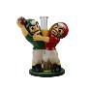
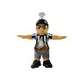
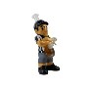
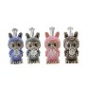
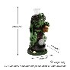
Product No. Picture Weight SPECS
Landed Price by USPS

Stock

10.4'' Soccer party water pipe

10.4'' Soccer shoes water pipe

10.6'' Zombie shark water pipe

10.4'' Dolphin water pipe

11.4'' Lionel Messi water pipe

8.8'' Corpse flower water pipe

8'' Sunglasses duck water pipe

6.8'' Penguin Modi water pipe

6.6'' Penguin Rick water pipe

11'' Artistic couple water pipe

11'' Players competing water pipe

11.8'' Penalty referee water pipe

11.8'' Individual foul referee water pipe

6.1'' Small size Labubu water pipe(Flannel surface)

9.2'' Headless knight water pipe

H593 494 g

H592 550 g

H577 718 g

H575 705 g

H570 595 g

H564 527 g

H562 323 g

H559 114 g

H558 142 g

H557 516 g

H560 650 g

H553 567 g

H552 547 g

H543-A 117 g

H536 520 g
pvc+glass 265*130*150mm

pvc+glass 265*110*180mm

pvc+glass 270*100*165mm

pvc+glass 265*135*165mm

pvc+glass 290*130*190mm

pvc+glass 225*110*140mm

pvc+glass 205*100*155mm

pvc 175*115*150mm

pvc 170*110*150mm

glass 280*100*140mm

pvc+glass 280*170*230mm

pvc+glass 300*130*280mm

pvc+glass 300*170*280mm

pvc 157*80*140mm

pvc+glass 234*116*140mm

$22.0 108 pcs

$22.4 198 pcs

$21.5 122 pcs

$20.9 138 pcs

$22.2 204 pcs

$20.0 107 pcs

$19.2 113 pcs

$11.8 191 pcs

$11.8 190 pcs

$21.5 164 pcs

$27.0 108 pcs

$23.0 120 pcs

$20.2 122 pcs

$10.9 180 pcs

$20.1 229 pcs

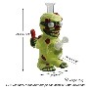
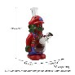
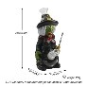
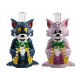
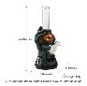
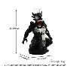
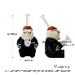
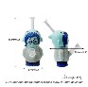
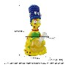
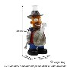
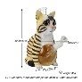
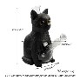
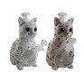
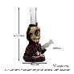
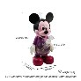
Product No. Picture Weight SPECS
Landed Price by USPS

Stock

7.29'' Lollipop mummy water pipe

9.2'' Zombie mario water pipe

8.9'' Zombie witch water pipe

10.4'' Tom cat water pipe

10.5'' The Hand of Fear water pipe

9.6'' Alien Spider-Man water pipe

6.1'' Peter docter water pipe

7.1'' Sadness water pipe

11'' Octopus Marge water pipe

10.9'' Steel Claw Homer water pipe

8.8'' Tabby cat water pipe

8.8'' Black tabby cat water pipe

8.8'' Cat water pipe with printing

10.3'' Gastly water pipe

10.5'' Minnie mouse water pipe

H535 563 g

H532 535 g

H528 520 g

H527 645 g

H522 450 g

H519 346 g

H512 121 g

H511 152 g

H507 469 g

H506 485 g

H497 345 g

H497-A 345 g

H497P 345 g

H496 460 g

H492-A 541 g
pvc+glass 234*131*149mm

pvc+glass 234*133*137mm

pvc+glass 226*114*135mm

pvc+glass 266*164*213mm

pvc+glass 267*102*143mm

pvc+glass 245*133*160mm

pvc 155*90*106mm

pvc 182*87*119mm

pvc+glass 279*133*170mm

pvc+glass 276*136*141mm

pvc+glass 224*112*180

pvc+glass 225*113*180mm

pvc+glass 225*113*180mm

pvc+glass 263*111*132mm

pvc+glass 268*156*90mm

$20.0 323 pcs

$17.5 102 pcs

$18.0 138 pcs

$24.5 171 pcs

$19.7 153 pcs

$20.9 144 pcs

$10.4 120 pcs

$7.4 120 pcs

$23.9 113 pcs

$23.6 187 pcs

$22.4 129 pcs

$22.4 121 pcs

$23.1 110 pcs

$22.0 101 pcs

$23.6 203 pcs

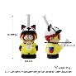
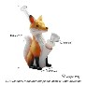
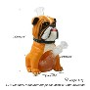
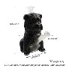
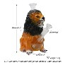
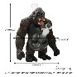
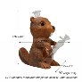
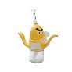
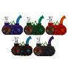
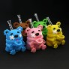
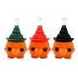
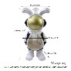
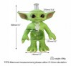
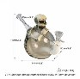
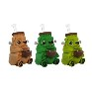
Product No. Picture Weight SPECS
Landed Price by USPS

Stock

6.5'' Kenny water pipe

6.6'' Little fox water pipe

8.6'' Bulldog water pipe

8.6'' Black Bulldog water pipe

9'' Lion water pipe

9.8'' Gorilla water pipe

8.7'' Beaver water pipe

8.9'' Banana water pipe

Radio water pipe

4.9'' Tongue-sticking bear water pipe

6.6'' Silicone pumpkin wizard hat water pipe

11.5'' pvc backpack rabbit

12'' Yoda water pipe

5.8'' pvc skull water pipe

Zombie pug water pipe

H484 156 g

H485 128 g

H475 477 g

H475-A 477 g

H473 541 g

H471 634 g

H466 530 g

H463 307 g

H452 157 g

H451 161 g

H445 173 g

H425 561 g

H353 640 g

H388 263 g

H381 185 g
pvc 165*80*114mm

pvc 170*52*127mm

pvc+glass 220*119*204mm

pvc+glass 220*119*204mm

pvc+glass 230*120*205mm

pvc+glass 249*204*163mm

pvc+glass 221*130*214mm

pvc+glass 136*178*226mm

silicone 118*50*108mm

silicone 125*85*90mm

silicone 168*95*112mm

pvc+glass 155*148*293mm

pvc+glass 270*124*306mm

silicone+glass 200*112*148mm

silicone 160*88*84mm

$11.3 119 pcs

$10.4 160 pcs

$22.2 112 pcs

$22.2 160 pcs

$22.3 124 pcs

$23.9 169 pcs

$22.9 134 pcs

$17.3 126 pcs

$10.3 946 pcs

$8.7 556 pcs

$9.0 602 pcs

$22.2 116 pcs

$22.4 247 pcs

$17.1 149 pcs

$10.8 797 pcs

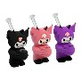

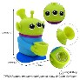
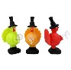
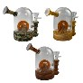
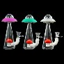
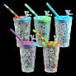

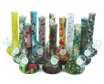
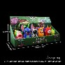
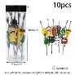
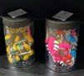
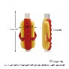
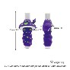
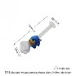
Product No. Picture Weight SPECS
Landed Price by USPS

Stock

Kuromi water pipe

Expression cactus water pipe

Three eyes guy

Turkey water pipe

Waterwheel water pipe

UFO water pipe

Freeze cooling cup bubbler

7.5'' beaker water pipe

7.5'' beaker water pipe

Mixed hand pipes 18pcs/display

Dab tools mixed 10pcs/jar

Roach clips mixed 15pcs/set

Hot dog straight tube glass pipe

Purple mushroom straight tube glass pipe

Sonic glass hand pipe

H371 150 g

H321 124 g

H254 166 g

H248 170 g

H194 225 g

H154 215 g

H95 420 g

H4 150 g

H4P 150 g

H462 763 g

B033 212 g

B002 170 g

H538A 38 g

H538B 32 g

H468A 30 g
silicone 144*79*94mm

silicone 146*47*104mm

silicone 120*77*57mm

silicone 170*90mm

silicone+glass 123mm*75mm

silicone+glass 180*64mm

silicone+plastic cup 157*95mm (6.1"*3.7")

silicone 190*55*80mm.

silicone 190*55*80mm.

display box 325*121*129mm

150*55mm

150*55.6mm

silicone 83*21*41mm

silicone 83*25*41mm

silicone+glass 112*30mm

$11.7 592 pcs

$8.8 110 pcs

$10.3 343 pcs

$9.8 195 pcs

$13.3 180 pcs

$12.6 462 pcs

$14.3 228 pcs

$9.2 200 pcs

$9.7 100 pcs

$34.8 131 displays

$14.3 152 jars

$11.9 199 jars

$6.4 219 pcs

$6.4 187 pcs

$6.7 489 pcs

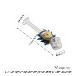
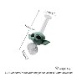
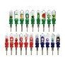
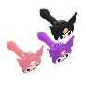
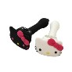
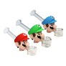
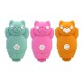
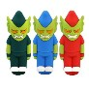
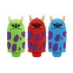
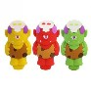
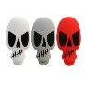
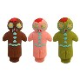

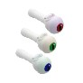
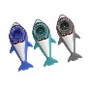
Product No. Picture Weight SPECS
Landed Price by USPS

Stock

Rick glass hand pipe

Yoda glass hand pipe

6.5'' Plastic nectar collector (steel nail)

Kuromi hand pipe

Kitty big hand pipe

Mario glass hand pipes

Puppet bear hand pipe

The boy hand pipe

Spotted monster hand pipe

Barbarian hand pipe

Skull hand pipe

The Gingerbread Man hand pipe

Smiley Ghost hand pipe

Eye hand pipe

Shark hand pipe

H468B 32 g

H468C 44 g

H435-2 83 g

H378 57 g

H377 60 g

H363 53 g

H455 33 g

H454 19 g

H453 23 g

H440 27 g

H439 26 g

H438 20 g

H436 32 g

H434 25 g

H401 17 g
silicone+glass 113*42mm

silicone+glass 112*71mm

plastic 167*32mm

silicone 112*51*74mm

silicone 114*68*42mm

124*58mm

silicone 46*32*77mm

silicone 30*24*78mm

silicone 79*25*35mm

silicone 78*42*35mm

silicone 81*28*41mm

silicone 78*44*25mm

silicone 78*46*35mm

silicone 92*35*36mm

silicone 79*31*36mm

$6.9 282 pcs

$6.9 281 pcs

$7.4 277 pcs

$6.8 379 pcs

$6.8 276 pcs

$7.2 280 pcs

$6.0 546 pcs

$6.0 500 pcs

$6.0 1041 pcs

$5.9 861 pcs

$6.0 486 pcs

$6.0 1222 pcs

$6.0 464 pcs

$6.0 478 pcs

$6.0 193 pcs

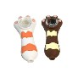

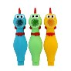
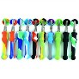
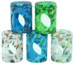
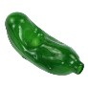
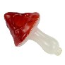

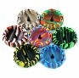
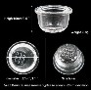
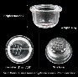
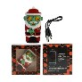
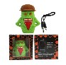
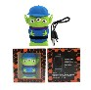
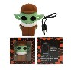
Product No. Picture Weight SPECS
Landed Price by USPS

Stock

Cat paw hand pipe

Naked lady hand pipe

Screaming chicken pipe

6.6'' nectar collector

180ml flower jar

Cucumber glass pipe

Mushroom glass pipe

Pea glass pipe

eometric Ashtray

Big 9 holes glass bowl

Small 9 holes glass bowl

Santa clus internal CBD battery device

Monster internal CBD battery device

Alien internal CBD battery device

Yoda internal CBD battery device

H400 21 g

H308 23 g

H240 38 g

H129 57 g

J1P 177 g

WS158 41 g

WS155 34 g

WS156 34 g

A3 182 g

P001 7 g

P002 5 g

E23 78 g

E9 102 g

E8 85 g

E7 94 g
silicone 81*22*35mm

silicone 80*32mm

silicone 35*141mm

silicone 170mm(6.6")

180ml 96*71mm
including dab tool

glass 102*38mm

glass 96*61mm

glass 95*40mm

silicone 128*32mm

Height: 16mm Diameter: 27mm

Height: 152mm Diameter: 14mm

Battery Capacity:650mAh Charging Port:Type-C

Battery Capacity:650mAh Charging Port:Type-C

Battery Capacity:650mAh Charging Port:Type-C

Battery Capacity:650mAh Charging Port:Type-C

$6.0 377 pcs

$6.0 935 pcs

$6.6 187 pcs

$7.5 398 pcs

$7.4 346 pcs

$7.5 157 pcs

$7.5 151 pcs

$7.5 104 pcs

$7.9 179 pcs

$5.8 3140 pcs

$5.7 2510 pcs

$7.7 431 pcs

$7.7 1633 pcs

$7.7 919 pcs

$7.7 399 pcs

